YOU NEVER WALK ALONE
More than a fandom, more than music – a connection beyond boundaries.
Somewhere in the world, there are seven boys whose voices have reached millions of hearts. And somewhere across those millions of hearts lives a name – ARMY.
ARMY is not just a fandom. It is a family built through music, emotions, memories, and an unbreakable connection. It is a place where millions of strangers, speaking different languages, living in different countries, and carrying different stories, somehow find a common home.
The story of BTS and ARMY is not simply about artists performing on a stage and fans cheering from below. It is about seven people who started with dreams, struggles, and uncertainty, and millions of people who found pieces of themselves in their words.
BTS never limited their music to one language, one culture, or one generation. Their songs speak about youth, loneliness, self-love, heartbreak, dreams, courage, and the beauty of being yourself. Whether it is the comforting message of Magic Shop, the hope in Mikrokosmos, the warmth of Spring Day, or the reminder of Love Myself, their music has become a source of comfort and inspiration for people around the world.
And perhaps that is what makes this connection so special.
There is no age limit to being ARMY. No colour, gender, nationality, religion, language, or border can define who gets to be a part of this family. You don't need to look a certain way, speak a particular language, or come from a specific place. You simply need a heart that finds meaning in their music.
Some discovered BTS during their happiest moments, while others found them during difficult chapters of life. Some came for the music and stayed for the personalities, while others found friendship, confidence, and a sense of belonging along the way.
You might be listening to Life Goes On on a difficult day, finding courage in Not Today, feeling understood through The Truth Untold, or simply smiling while watching seven boys being themselves. Every ARMY has a different story, but somehow, those stories meet in the same place.
And BTS have never forgotten the people who walked beside them throughout their journey. Through their music, letters, performances, and heartfelt messages, they have continuously expressed their gratitude and love for ARMY.
The relationship between BTS and ARMY is built on mutual support. BTS create music that touches hearts, and ARMY give that music a life beyond the stage. Their voices meet in concert halls, their memories live through albums and photographs, and their connection continues even when thousands of miles separate them.
Perhaps the most beautiful thing about this fandom is that you don't have to know every song, own every album, attend every concert, or follow every update to belong. Being ARMY is not a competition. It is about the connection you feel and the memories you choose to keep.
Because at the end of the day, BTS is not just seven names on a screen, and ARMY is not just a crowd holding purple light sticks.
They are seven artists and millions of hearts connected by something that words can never fully explain.
Different lives. Different stories. Different corners of the world. But one beautiful connection.
And wherever life takes us, one message will always remain:
"YOU NEVER WALK ALONE."
Borahae – Until the last purple light shines. 💜

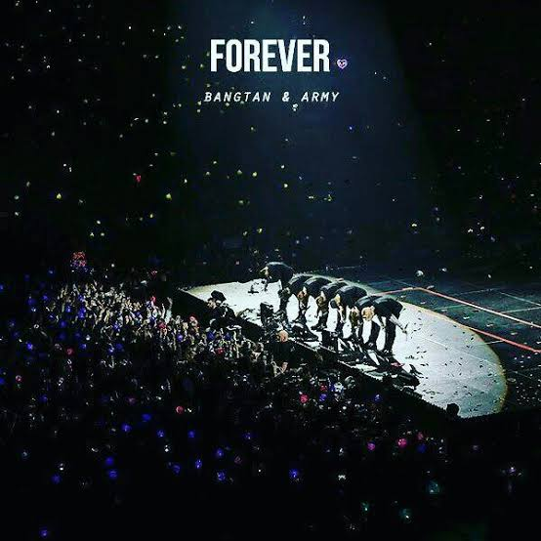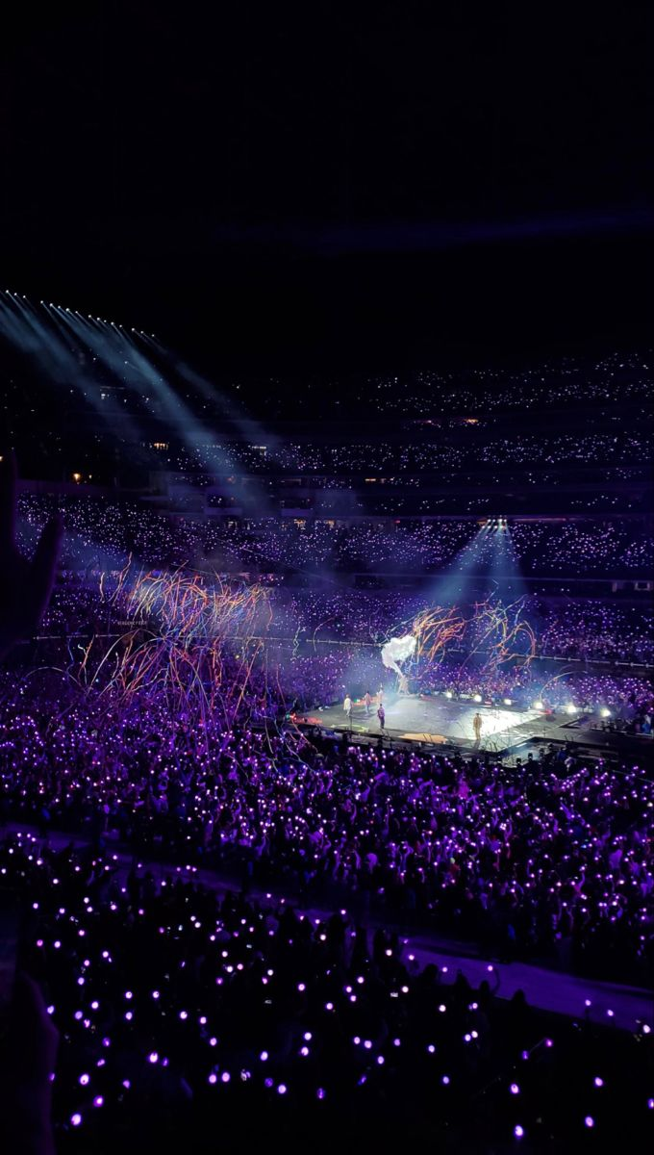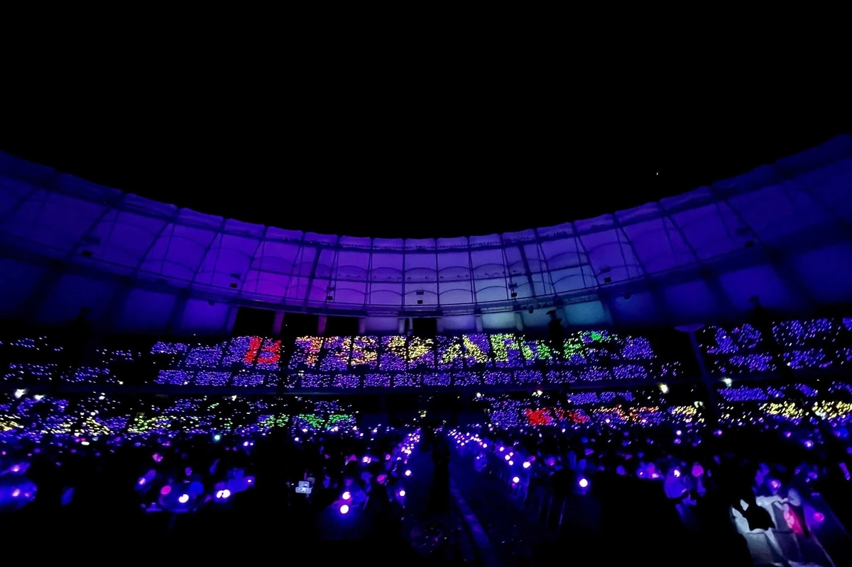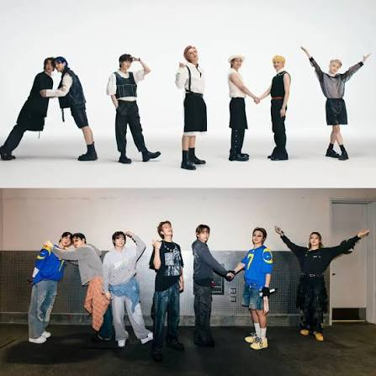
WE BELONGS TO ARMY

